Analysis of Manchester's Urbanisation Process Based on the Differential Urbanisation Model

|  |  |
| --- | --- |
| *Word Count (excluding list of references):* | *953* |

# Introduction

The Differential Urbanisation Model (DU Model) determines the urbanisation process of a region through patterns of population migration, characterised by the temporal sequence of net population growth rates in primate, intermediate and small cities, dividing the urbanisation process into six stages (Geyer and Kontuly, 1993). Manchester, as the first industrialised city in the world, went through a relatively complete urbanisation phase. The analysis of Manchester and its related areas based on the DU Model will allow for a more accurate model test and clarify Manchester's urbanisation process.

# Research Area

Manchester is generally regarded as a metropolitan area including several boroughs, with several similar but different definitions. For statistical consistency and research convenience, Greater Manchester is defined as the research area, it is a metropolitan county and combined authority area, with a population of 2.8 million in 2021 (Authority, 2022), making it the second most populous urban area in the UK and one of the primate cities in North West England.

# The urbanisation Stage Division

## I. Early Primate City Stage (1760s-1800s)

Until the early 18th century, Manchester was a market town of around 10,000 people, with a textile industry as its mainstay (Lambert, 2021). From the 1760s, benefits to its easy access to rail and water transport and the proximity to material sources, Manchester gradually became one of the textile manufacturing centres during the Industrial Revolution (McNeil and Nevell, 2000). The creation of factories created massive jobs and attracted lots of people, leading to the beginning of urbanisation. During this period, Manchester as a primate city began to attract the population of the surrounding intermediate sized cities and small cities.

## II. Intermediate Primate City Stage (1800s-1850s)

With the advancing Industrial Revolution around the 1800s, Manchester rapidly became an important industrial city as the widespread use of Watt's steam engine in textile factories promoted the development of related industries, and massive factories were set up (Hall, 1998). Meanwhile, with the benefits of the advances in transport brought by the Industrial Revolution, several intermediate sized cities along railways or canals such as Stockport and Bolton began to develop with the rise of Manchester (Gregory and Henneberg, 2010). During this period, Manchester enters its fastest urbanising phase with near-record population growth, while the rates of the surrounding intermediate sized cities turned from negative to positive, but there was a further outflow of population from the small cities.

## III. Advanced Primate City Stage (1850s-1900s)

Along with rapid development, Manchester's industrialisation led to a deteriorating urban environment, and with the widespread influence of ideas such as the Garden City, the city's middle class began to migrate to suburbs and small cities (Ward, 1992). Meanwhile, the number of textile factories in Manchester peaked in the 1850s, before being surpassed by the intermediate sized cities of Bolton and Oldham (McNeil and Nevell, 2000). During this period, Manchester's net population growth rate peaked and then declined, while intermediate sized cities’ rate continued to rise, the small cities began to develop with benefited from the better environment and the population outflow trend was reduced.

## IV. Early Intermediate City Stage (1900s-1950s)

Around the 1900s, the urbanisation progress in Britain reached 70-80% and then slowed down. At a time when Manchester’s traditional industries are in decline, the Great Depression and World War II took a huge toll on its industry and infrastructure. These factors caused a significant drop in Manchester's population. Meanwhile, the car’s popularity and the development of the Satellite Town theory led to the construction of small cities around Manchester, represented by Wythenshawe, the main function is suburban living (Ward, 1992). During this period, the net population growth rate of intermediate sized cities was the highest while the rate of primate cities continued to decline and that of small cities increased rapidly, showing the characteristics of a polarisation reversal.

## V. Advanced Intermediate City Stage (1950s-1960s)

After World War II, Overspill estates were built on the suburban of large cities to solve the housing problem of overpopulation in urban areas, and Hattersley and Gamesley on the suburban of Manchester were created at this time (Cullingworth, 2003). The net population growth rate of the small cities overtook that of the primate cities around 1950, crossing the clean break from Stage IV to Stage V (Champion, 2003).

## VI. Small City Stage (1960s-2000s)

Since the 1960s, Manchester's textile and shipping industries have succumbed to difficulties, the city's economic downturn led to job losses, and its central city has been limited by premature urbanisation to a 19th-century spatial structure filled with industrial areas and old housing (Rodgers, 2022). Therefore, Manchester experienced a massive outflow of the population, and into the counter-urbanisation stage during this time. Meanwhile, the construction of new towns such as Warrington around Manchester (Bull, 1967), not only exacerbated its population outflow, but also represented the small cities that dominated this stage.

## The Next Cycle (2000s-)

After the 1990s, following a long period of decline, Manchester embarked on a property-led urban regeneration strategy, with Manchester's central city experiencing extensive redevelopment and a shift in the dominant industry from industry to services, attracting an influx of people (Ortiz-Moya, 2015). After the 2000s, Manchester's net population growth became positive and concentrated again in the central city (Figure 1,2), entering the next cycle of urban development.

***Figure 1****. Greater-Manchester Population Growth Rate Change, 1801-2021; Note: Missing data were interpolated using mean values (GB Historical GIS / University of Portsmouth, 2021)*

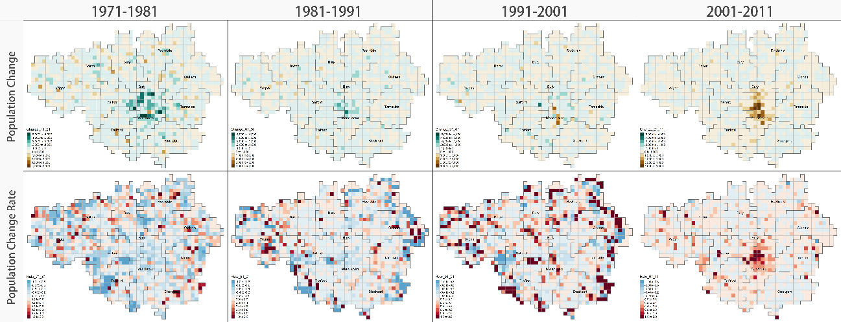

***Figure 2****. Greater-Manchester Population Change Grid, 1971-2011 (Lloyd et al., 2018)*

# Conclusion

In summary, the DU model is well validated for Manchester and its surrounding area, with each stage clearly divided and in line with the law of urbanization development in the region. The model may not match perfectly during particular periods such as war and recession, but this does not affect the overall interpretation. For Manchester, the urban development process that began in the 1760s can be divided into six stages, while from the 2000s, Manchester's urban development begins a new cycle.

# References

Authority, G.M.C. (2022) *Census 2021: First Results, Greater Manchester Combined Authority*. Available at: <https://www.greatermanchester-ca.gov.uk/what-we-do/research/research-demographics/census-2021-first-results/> (Accessed: 7 November 2022).

Bull, D.A. (1967) ‘New Town and Town Expansion Schemes: Part I: An Assessment of Recent Government Planning Reports’, *The Town Planning Review*, 38(2), pp. 103–114.

Champion, T. (2003) ‘Testing the differential urbanisation model in Great Britain, 1901–91’, *Tijdschrift voor Economische en Sociale Geografie*, 94(1), pp. 11–22. Available at: <https://doi.org/10.1111/1467-9663.00233>.  
Cullingworth, J.B. (2003) ‘Housing needs and planning policy: A restatement of the problems of housing need and “overspill” in England and Wales’, pp. 1–218. Available at: <https://doi.org/10.4324/9780203001257>.

GB Historical GIS / University of Portsmouth*, Greater Manchester Met.C through time | Population Statistics | Total Population, A Vision of Britain through Time.* (2021). Available at: <https://www.visionofbritain.org.uk/unit/10056925/cube/TOT_POP> (Accessed: 7 November 2022).

Geyer, H.S. and Kontuly, T. (1993) ‘A Theoretical Foundation for the Concept of Differential Urbanization’, *International Regional Science Review*, 15(2), pp. 157–177. Available at: <https://doi.org/10.1177/016001769301500202>.

Gregory, I.N. and Henneberg, J.M. (2010) ‘The Railways, Urbanization, and Local Demography in England and Wales, 1825–1911’, *Social Science History*, 34(2), pp. 199–228. Available at: https://doi.org/10.1017/S0145553200011214.

Lambert, T. (2021) ‘A History of Manchester’, *Local Histories*, 14 March. Available at: <https://localhistories.org/a-history-of-manchester/> (Accessed: 7 November 2022).

Lloyd, C. *et al*. (2018) *PopChange population grids for Britain, 1971-2011*. UK Data Archive. Available at: <https://doi.org/10.5255/UKDA-SN-852498>.

McNeil, R. and Nevell, M. (2000) *A Guide to the Industrial Archaeology of Greater Manchester*. Association for Industrial Archaeology.

Ortiz-Moya, F. (2015) ‘Coping with shrinkage: Rebranding post-industrial Manchester’, *Sustainable Cities and Society*, 15, pp. 33–41. Available at: <https://doi.org/10.1016/j.scs.2014.11.004>.

Peter Geoffrey Hall (1998) *Cities in civilization*. Weidenfeld & Nicolson. Available at: <http://archive.org/details/citiesinciviliza00hall> (Accessed: 7 November 2022).

Rodgers. (2022). *Manchester - Evolution of the modern city | Britannica*. Available at: <https://www.britannica.com/place/Manchester-England/Evolution-of-the-modern-city> (Accessed: 7 November 2022).

Ward, S. (1992). *The Garden City: Past, present and future (1st ed.)*. Routledge. <https://doi.org/10.4324/9780203973615>.